IBM ASSIGNMENT 2

|  |  |
| --- | --- |
| Name | Pramoth G |
| Register Number | 2019503574 |
| Project Title | Global Sales Data Analytics |
| College | Madras Institute of Technology, Anna University |

**Task 1: Sales by Customer.**

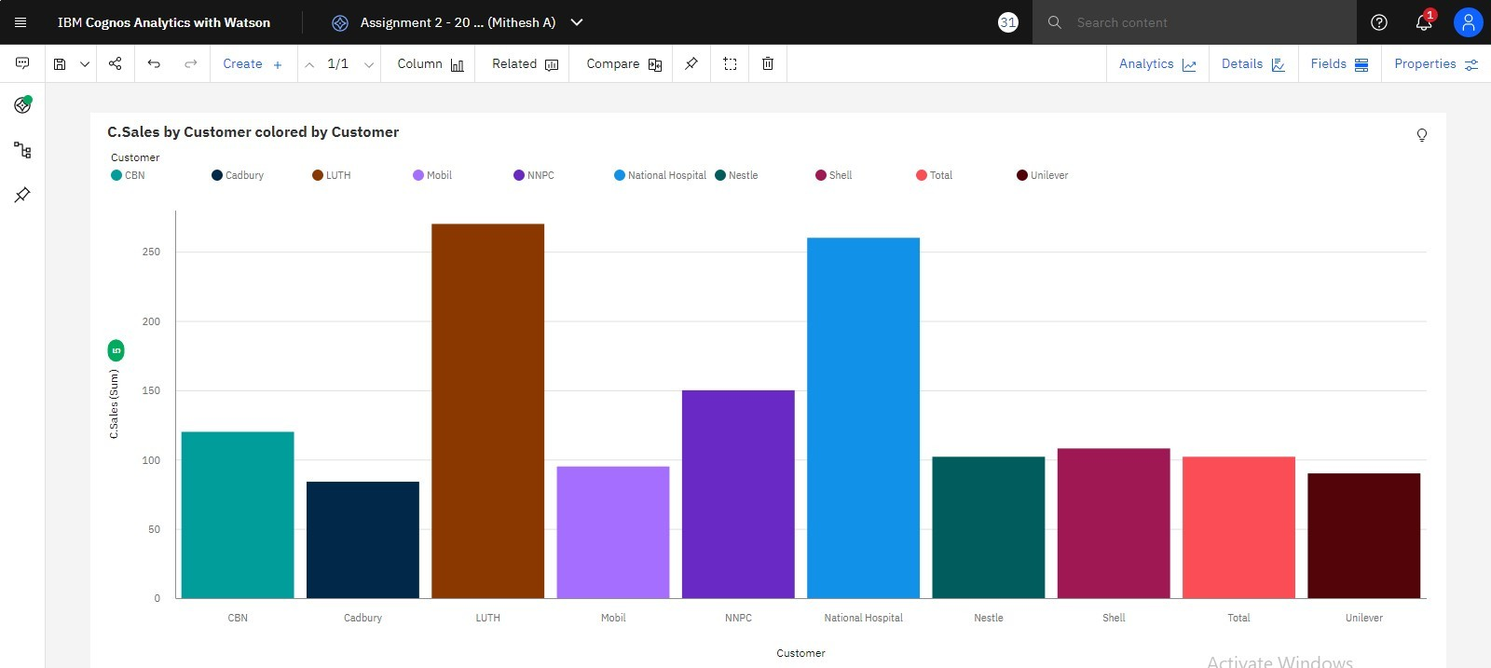

**Task 2: Sales by Location.**

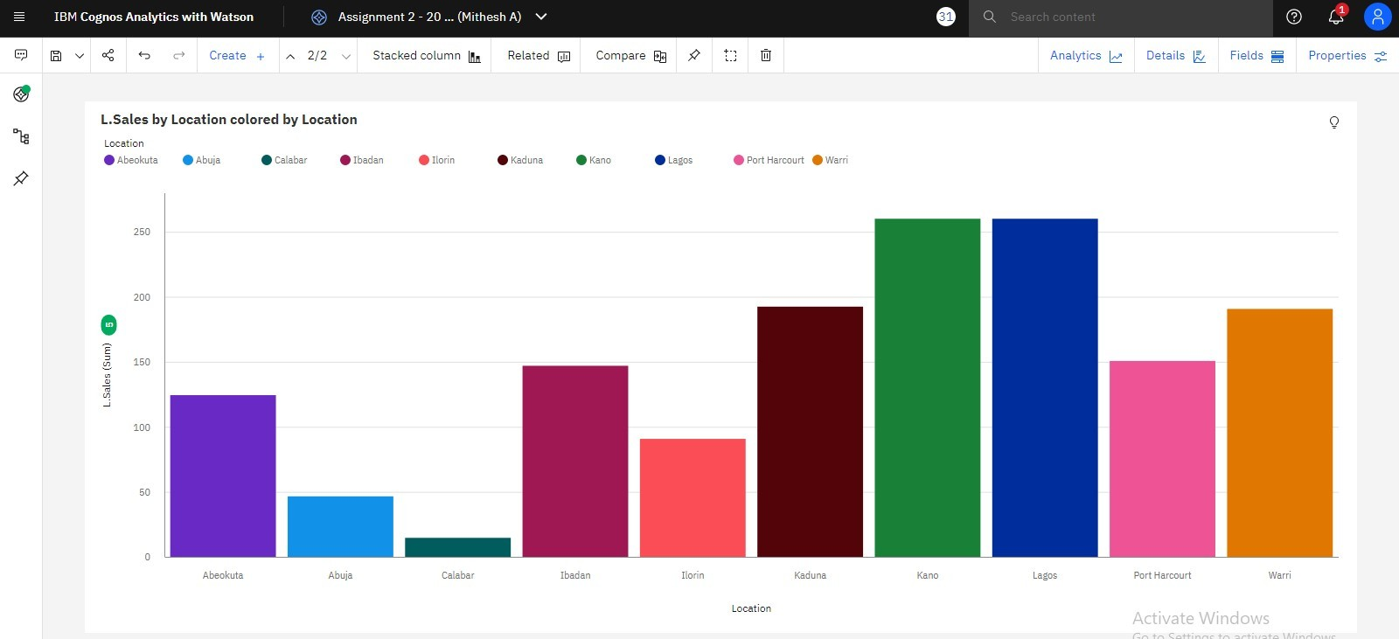

**Task 3: Sales by Sales Representative.**

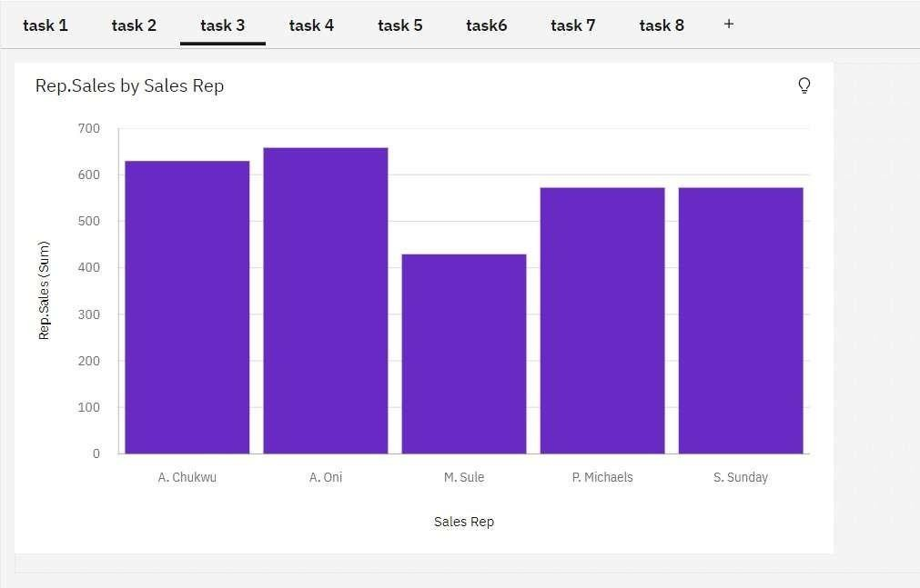

**Task 4: Received Inventory from Supplier**

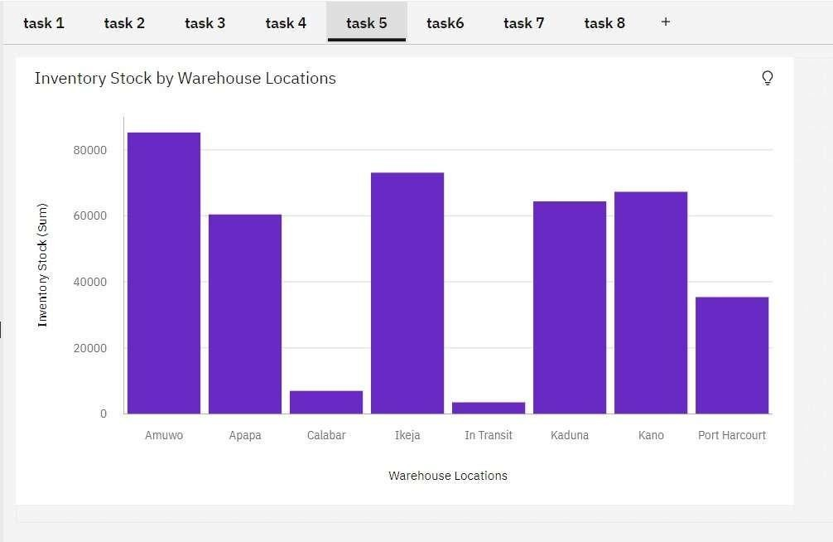

**Task 5: Inventory Stock for Warehouse Locations**

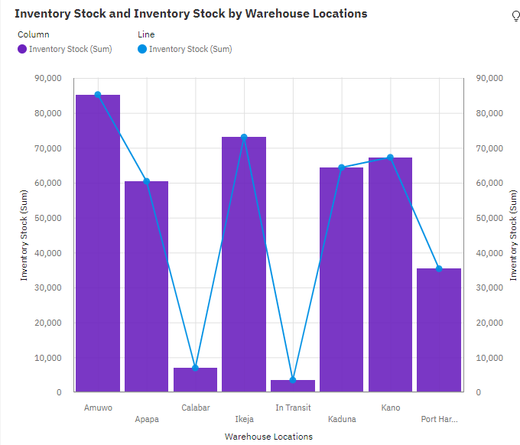

**Task 6: Sales Trend**

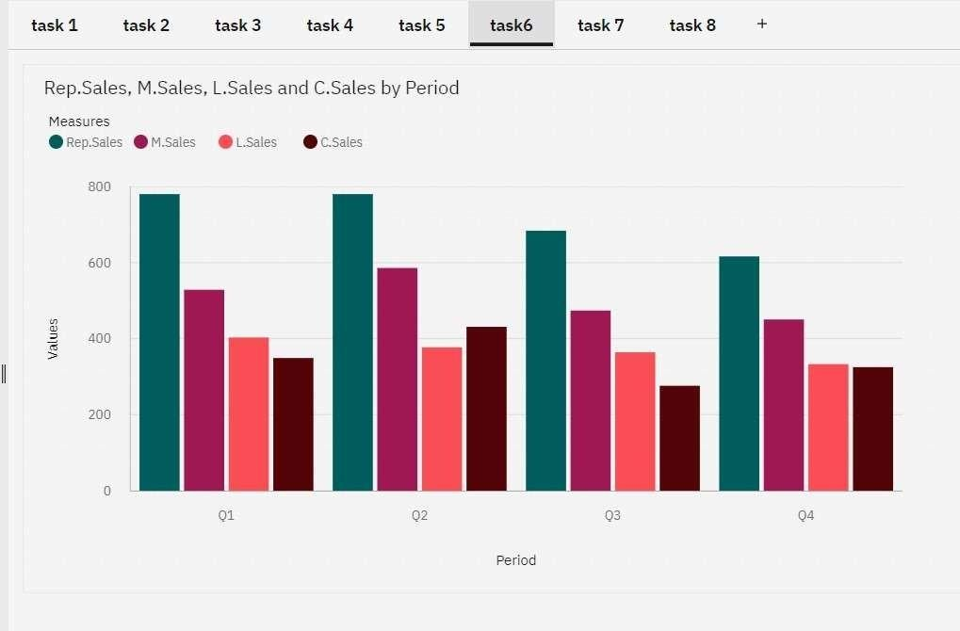

**Task 7: Monthly Sales**

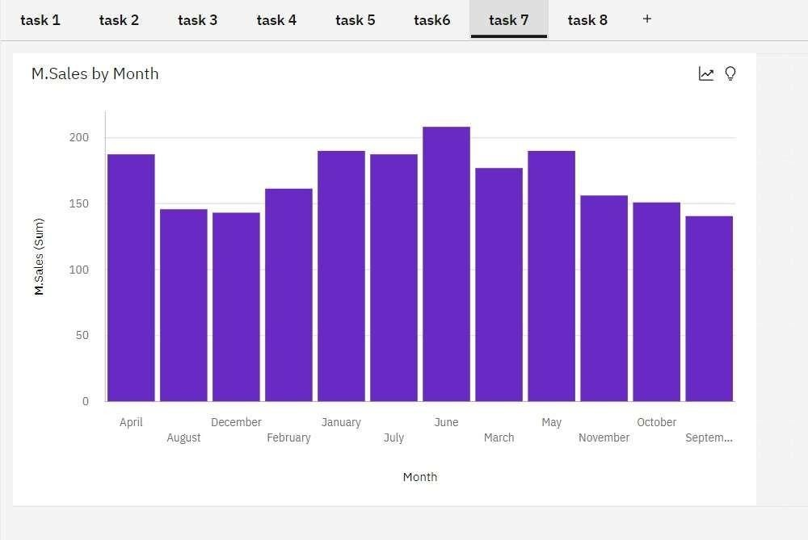

**Task 8: Actual and Received Inventory by Month﻿**

